BIOC 300D2
Lecture 4 – Selection of Recombinants
P. Gros – February 12, 2007

Plasmids

Episomes are relatively small circular genomes of size 2kb to 200kb that can replicate autonomously in bacterial cells, in a fashion and timing independent of replication of the bacterial host chromosomal DNA. In bacteria, the second major class of episomes is plasmids (last lecture was bacteriophage).

- Plasmids are circular DNA molecules in bacterial cell that replicate independently of the chromosome.
- They confer certain growth advantages to bacteria that carry them (fertility, antibiotic production and resistance, virulence determinants).
- The best example of growth advantage is the observation that resistance to many antibiotics such as tetracycline, ampicillin, chloramphenicol and others are encoded by genes carried on plasmids.
  - Gram-negative = E. coli, Pseudomonas aeruginosa, Salmonella typhi
  - Gram-positve = Staphyloococcus aureus, Streptococcus pneumoniae, Bacillus subtilis
- Plasmids are useful and widespread in molecular biology for :
  - Cloning DNA
  - Expression proteins in heterologous systems
  - Etc
- Certain plasmids, like the F plasmid of E. coli are present at a 1:1 ratio with the bacterial chromosome, while others, mostly small plasmids that carry a single gene, can be present as many as 200 copies per cell.
- There are a whole host of different plasmids that are used for specific jobs in the lab.

‘F’ Plasmid of E. coli

Historically, the first plasmids discovered was the ‘F’ (fertility) plasmid in E. coli during the early 1950’s. It is a very large, circular plasmid with a MW of 45x10⁶ daltons compared to the 2.9x10⁹ daltons for the E. coli chromosome.

- It is capable of autonomous replication.
- It confers certain properties on cell that contain it and these cells are termed F⁺ cells and those that don’t contain are termed F⁻ cells.
- The bacterial host is conferred the capacity to mate by a process known as conjugation.
- Conjugation involves the transfer of the F plasmid from a F⁺ cell to an F⁻ cell via a ‘conjugation pilus’, which is sort of like a bridge between the cell being infected and the F⁺ cell.
- The DNA is transferred as a linear molecule

Conjugation of F plasmid

The F⁺ cell will synthesize a conjugation pilus, which mediates contact with the F⁻ cell.
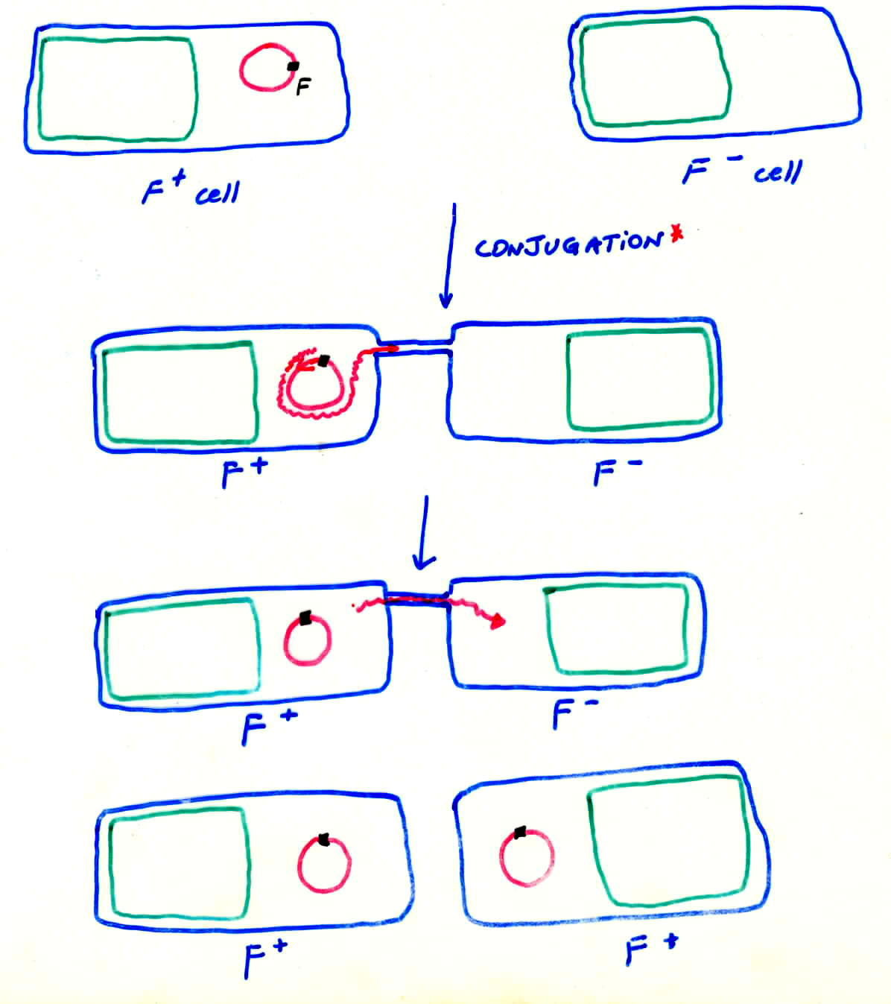
- As shown schematically to the left, the F plasmid is replicated and transfers as a linear molecule to the F⁻ cell through the conjugation pilus.
- Once inside the F⁻ cell, the F plasmid will recircularize and the F⁻ cell is now an F⁺ cell.

Creation of HFR strains
On occasion, but very infrequently, the F factor can integrate into the host chromosome by recombination and will replicate as part of the chromosome. In such it shares many of the properties of lysogenic bacteriophages.

- When the F plasmid becomes integrated at a specific site in the E. coli chromosome, the cell now is called a high frequency recombinant cell (Hfr cell).
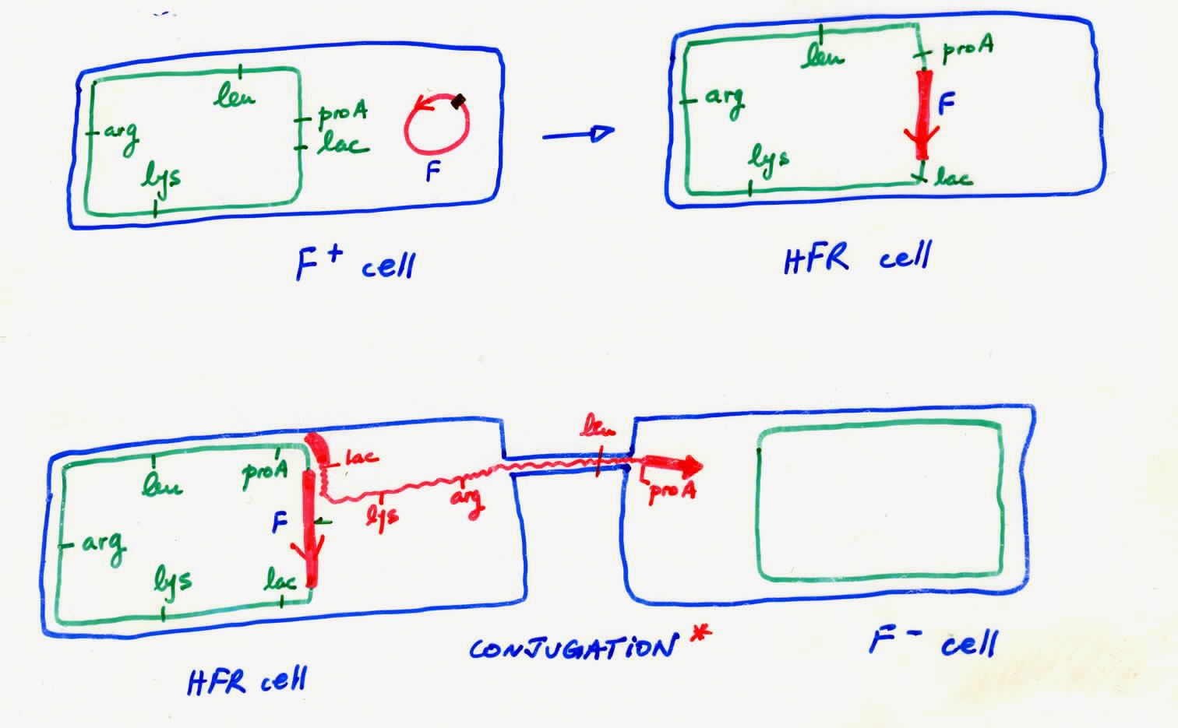
- This integrated factor confers new properties on the cell.
- This Hfr cell can mate (conjugate) at high frequency with F⁻ cells but now it can bring along a segment of the host chromosome along (i.e. recombination at high frequency).
- Because of the integrated F factor, the Hfr cell can form a conjugation bridge with an F⁻ cell.
- Replication will originate on the F sequence but can continue into the host chromosome and in such transfer a segment that can recombine with the F⁻ cell chromosome.
- The transfer takes some time (several minutes) and can be interrupted by mechanical disruption of the conjugation pilus; this allows one to find the distance between two genes.
- In early experiments, time-dependent correction of specific mutations in chromosomal genes by transfer of such F factors from the Hfr strains was used to establish the first circular chromosomal maps of E. coli where the position of the individual genes were expressed in minutes (110mintes).

F’ Plasmids

An integrated F plasmid in Hfr strains can excise itself from the host chromosome and become cytoplasmic.

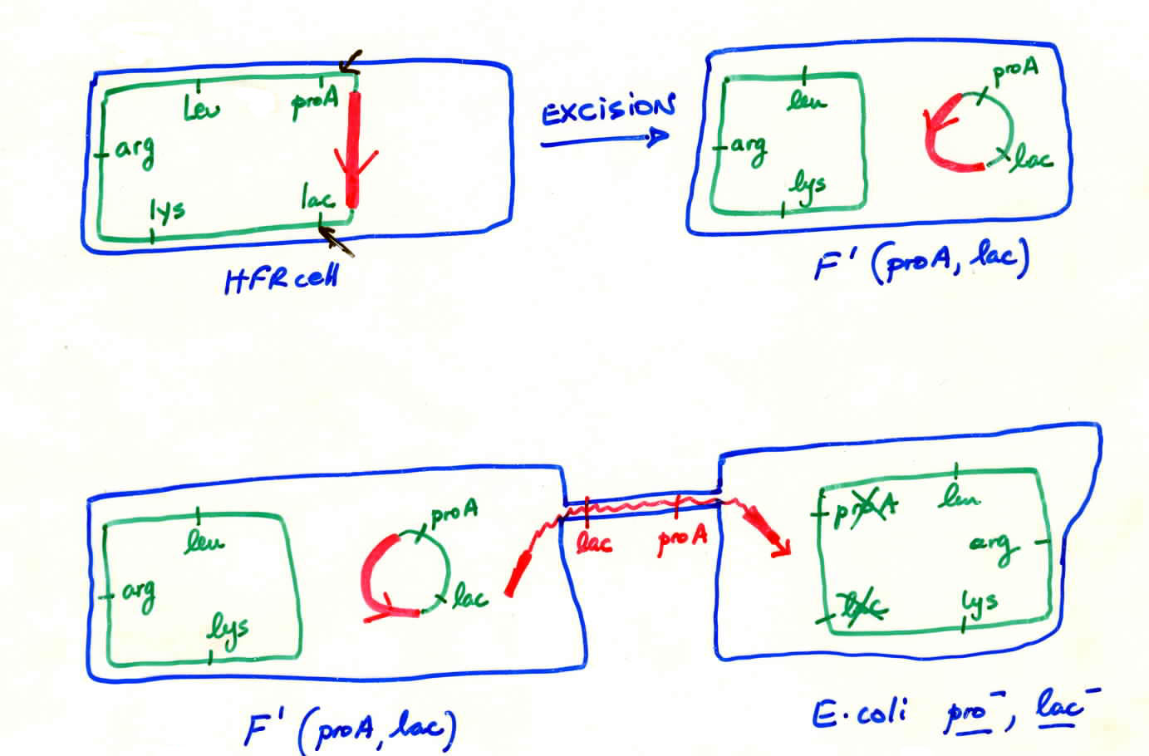
- This excision is not necessarily perfect and some host sequences may be excised.
- In such a process, the recombinant of F’ plasmid can confer novel properties to and F⁻ cell.
- As mentioned before, this can be used to complement a corresponding mutant.
- This can be seen the diagram above where a lac⁻/proA⁻ cell becomes lac⁺/proA⁺ upon conjugation with an F’ cell.

- The whole process mentioned above is a process known as horizontal transmission as opposed to vertical transmission, which is simply the transmission of a plasmid to each daughter cell when the bacterium divides.
- The great majority of plasmid vectors used in gene cloning do not however share these complex physiological features.

Features of Plasmids used in Molecular Biology

They are generally small (<10kb) and capable of propagating at high copy number in bacterial host. Here are some of the common features:

- Origin of replication (ORI) – this is a short DNA segment, which is recognized by the bacterial DNA polymerase and is used to copy the plasmid. The arrow indicates the direction of replication. With this the plasmid can replicate autonomously in the bacterial host.
- One or more antibiotic resistance genes – these are markers which allow one to select cells that carry the plasmid on plates that contain the antibiotic of interest. They permit identification of bacterial cell clones carrying the plasmid.
- Multiple cloning site (polylinker) – allows linearization of plasmid to which inserts can be introduced.
- Phenotypic marker – usually a colour maker that allows one to distinguish between plasmids that lack or contain a recombinant DNA insert.

- Additional features can be added to allow gearing for specific utility of plasmid (ex. simple cloning, recombinant protein production, shuttle in different organisms, protein expression and/or gene targeting in mammalian cells and many, many others).

Steps to Molecular Cloning in a Plasmid Vector

- Select appropriate plasmid vector (pUC19 for experiment 10)
- Linearize plasmid with a restriction enzymes (EcoRI) that cuts only once in the plasmid.
- Treat digested plasmid with calf intestinal phosphatase to remove terminal 5’ phosphate group (to prevent re-ligation).
- Purify digested plasmid away from leftover RE and CIP (phenol/chloroform extraction, gel electrophoresis).
- Prepare fragment to be cloned into plasmid (simple or complex mixture).
- Mix digested plasmid and DNA to be cloned, and add T4 phage DNA ligase to ligate the fragments together, which will reform the EcoRI site between the plasmid and mammalian DNA fragments.
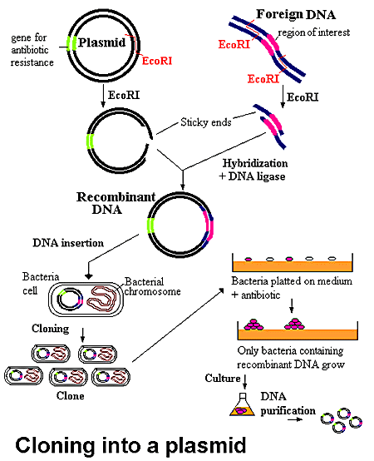
- Transform the mixture into “competent” E. coli bacteria. In this procedure, rapidly dividing bacteria are treated with CaCl₂ to render them competent to take up foreign DNA. They are then mixed with the recombinant plasmid. This is a very inefficient process and at best only 1 in 10000 bacteria will take up the plasmid.
- Plate transformants on selective medium and identify colonies containing either plasmid alone or recombinant plasmid (with an insert). To identify specifically bacteria containing the recombinant plasmid, Lac⁻/Amp^{s} E. coli cells transformed with the ligated DNA will be plated on medium containing ampicillin in X-gal. X-gal is a chromogenic dye that is broken down by β-galactosidase. Therefore, it allows distinction between Lac⁺ (green) and Lac⁻ (white) colonies.
- Pick colonies, grow up and analyze the presence of the desired plasmid.

Many plasmids have been isolate and have been modified for specific requirements. Following is a whole list of different plasmids and their properties:

pACYC177

- Bacterial plasmid
- Origin of replication
- Two antibiotics resistance genes
- Inactivation of one or the other can be used to identify recombinants

pLitmus

- Standard plasmid for molecular biology
- High copy number and small size
- Very large cloning polylinker
- Origin or replication
- Antibiotic resistance marker (Amp)
- LacZ phenotypic marker for detection of recombinant plasmids
- M13 Phage origin to produce ssDNA
- T7 polymerase priming sites near MCS for RNA transcription

pMAL
•Origin of replication
- •Drug resistance marker (Amp)
- Phenotypic marker (lacI)
- M13 origin for ssDNA and sequencing
- Fusion protein (mal E) to maltose binding protein (secreted in E. coli)
- Polylinker included in the malE gene for fusion
- Available with cleavage sites for 3 different proteases to release the expressed protein from the malE fusion

Yep24
•Yeast cloning vector
- Can replicate in bacterial and yeast cells
- Origins of replication for bacteria and yeast cells
- Selectable marker for bacteria (Amp/Tet) and yeast (URA3)

pGT-N28

- Plasmid vector used for germ-line modification in mouse cells
- Homologous recombination in embryonal stem cells
- Two MCS for cloning homologous segments from targeted gene
- Drug resistance marker for bacteria (Amp)
- Drug resistance marker in mammalian cells (neo) driven by PGK promotor

pUC19

- Plasmid you will use in the lab
- Small high copy plasmid
- Origin of replication
- Drug resistance marker (Amp)
- MCS in lacZ gene to identify recombinants

Restriction Endonucleases

Along with plasmids, restriction endonucleases constitute a second major tool in recombinant DNA technology as they constitute the ‘molecular scissors’ for the cleavage and engineering of recombinant DNA molecules.

- Restriction endonucleases have the capacity to cleave double stranded DNA
- They defend the bacteria by “restricting” the entry of foreign DNA such as bacteriophages.
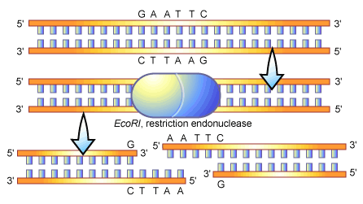
- Three classes of RE enzymes, type I, II, and III.
- Type I and III require ATP and can also methylate DNA.
- Type I enzymes cleave DNA randomly, while Type III recognize specific sequences within dsDNA and cleave DNA at or near such sites.

Type II Restriction Endonucleases

Type II enzymes have widespread use in molecular cloning.

- Their hydrolytic activity is not ATP-dependent.
- They cut within a specific nucleotide sequence, which is typically 4 to 6 nucleotides long.
- The sequence has a 2 fold axis of symmetry which is called a palindrome.
- For many enzymes, including EcoRI, the enzyme cleaves asymmetrically, and generates protruding single stranded 5’ ends. Others generate blunt products.
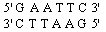
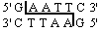

- The protruding “sticky” ends can form base pairs with one another.
- Importantly, if two fragments are derived from different origins, novel recombinant forms of DNA can be created: genetic engineering.

- There are many (>200) restriction enzymes available commercially.
- These all recognize either a) unique sequences or b) the same sequence but generating a different end (blunt, 5’ or 3’ overhangs).
- These can be used as molecular scissors to cut open DNA in specific places for recombination and engineering purposes.

Isoschizomers
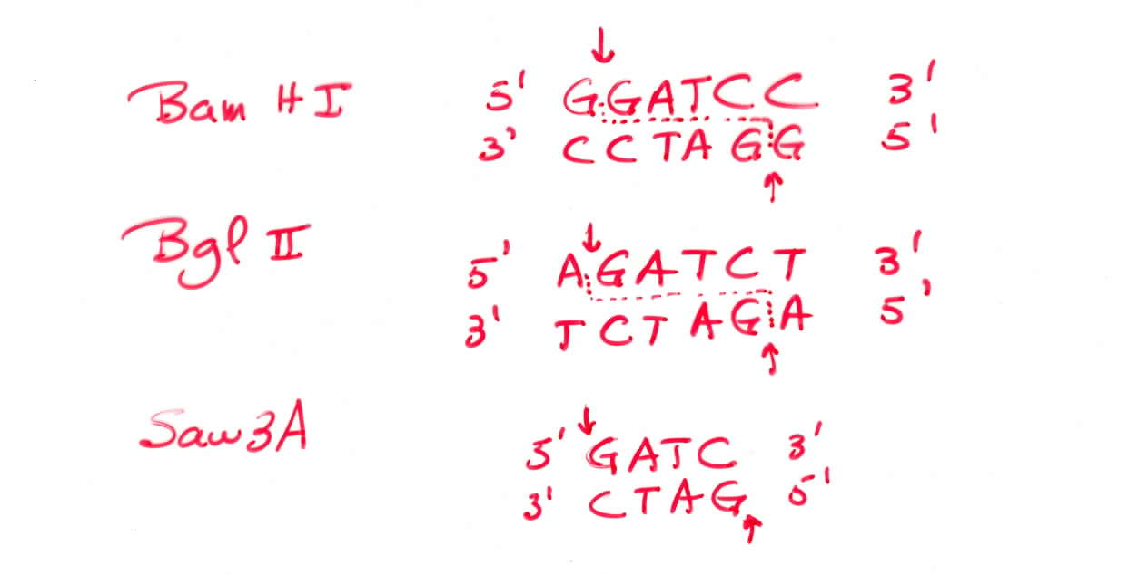
- Certain restriction enzymes recognize different sequences but contain the same core palindrome
- In this case, one can clone a fragment generated by one enzyme in the cleavage site generated by another enzyme (as in the example)
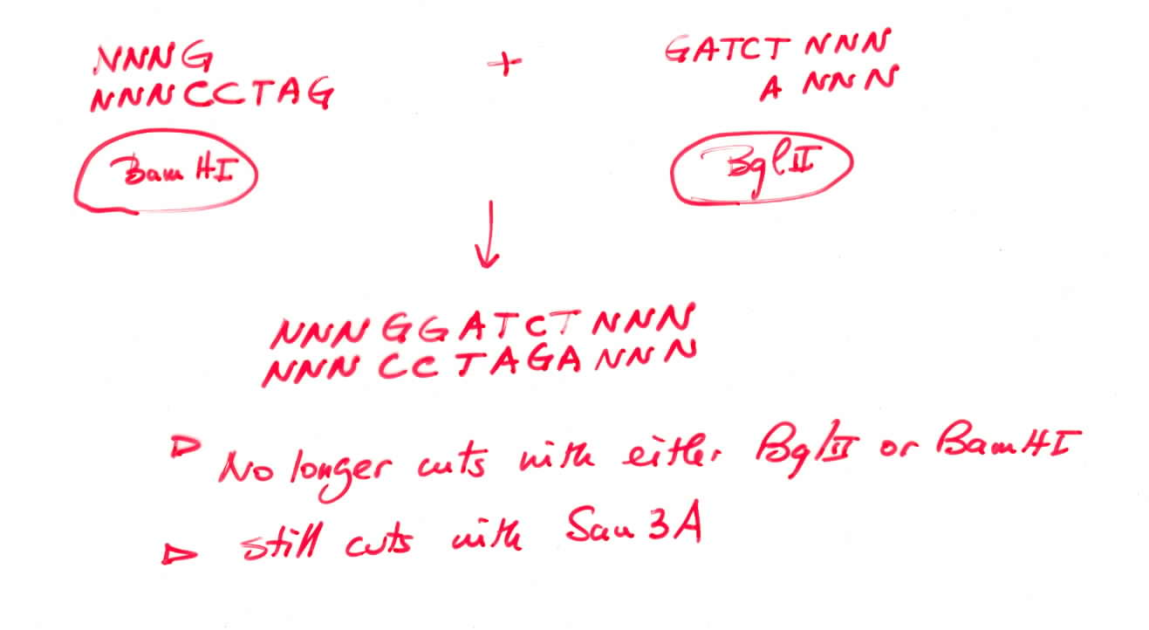
- In this case, the reconstituted site is no longer cleavable by either of the two enzymes

Restriction Mapping

Restriction mapping consists in establishing the position of restriction sites for specific enzymes in a fragment of DNA.

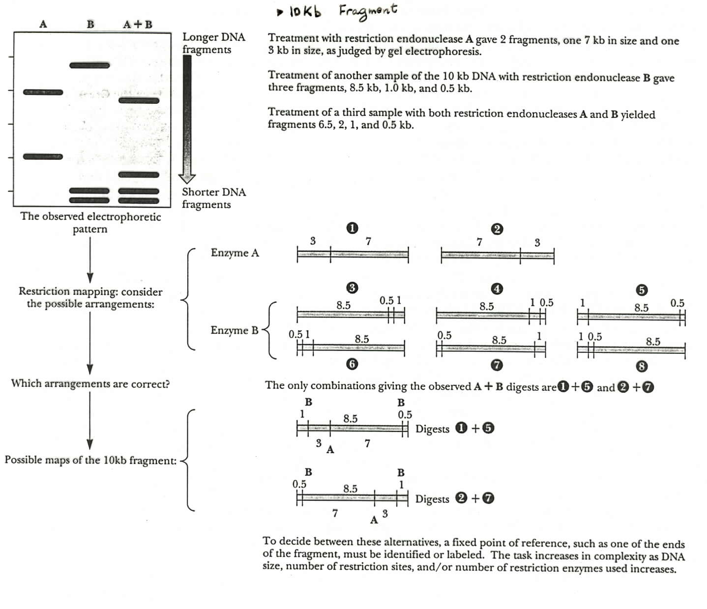
This can be useful for validating the presence of a specific insert in a plasmid (fingerprint), or to determine its relative orientation, or to create a sub-set of fragments or to cause deletions, etc.

- This is accomplished by making a series of digestions with single enzymes and sometimes with combination of enzymes.
- The products are then separated by electrophoresis on agarose or acrylamide gels and their sizes determined by a set of reference fragments (markers).
- The fragments migrate at rates inversely proportional to the log of their molecular weights.

(The rest of the lecture was not covered in class – most of it is protocol information. Here are the important points.)

Transformation

Two major techniques: Electroporation and calcium chloride-induced competent cells. Of interest for this experiment is the CaCl₂ transformation technique.

- In this technique, E. coli cells are grown to early log-phase, and treated on ice with CaCl₂.
- This treatment permeabilizes the cells, and facilitates adherence of DNA to the cell surface.
- The cells are then “shocked” by a brief incubation at 37ºC, which stimulates uptake of DNA by bacteria.
- The bacteria are allowed to recover, and to express the plasmid-encoded antibiotics-resistance gene, and are then plated on selective medium.
- You will use a selection that will distinguish cells that have received pUC19 plasmid from pUC19 plasmid with a DNA insert in the EcoRI site.

What are the critical parameters?

- E. coli cells must be rapidly dividing and in early log phase.
- E. coli cells have to be on ice throughout the whole procedure or cells will lyse.
- Times must be respected for exposure to CaCl₂ (ice and heat shock).
- Size of the DNA molecule (the larger the lower the efficiency).
- The quality of the DNA preparation (intact vs. degraded).
- The copy number of the plasmid once introduced in the E. coli cells.
- Stringency of selection strategy (one vs. two antibiotics).

